A) To update date and time on LoRa Node

1, Get Epoch time

https://www.epochconverter.com/

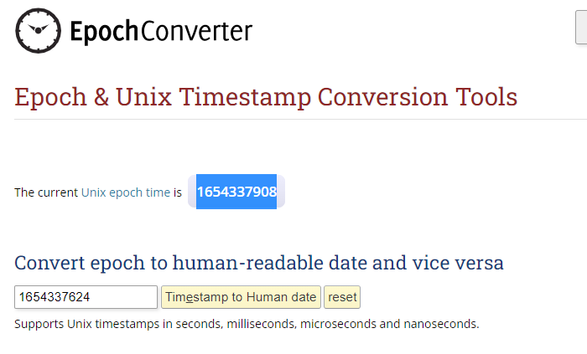
2, Convert number in Hex using a calculator

Exemple Epoch = 1654337629

=> 629B305D

3, Send Command using TTN

Syntax = Byte 0 Byte 1 Byte 2 Byte 3 Byte 4

Byte 0 = Command update date and time
Byte 1 to 4 = Epoch
Thus « 00 62 9B 30 5D » to be send

Exemple using : https://eu1.cloud.thethings.network/console/applications/letter-box-1/devices/eui-70b3d57ed0046e5b/messaging/downlink
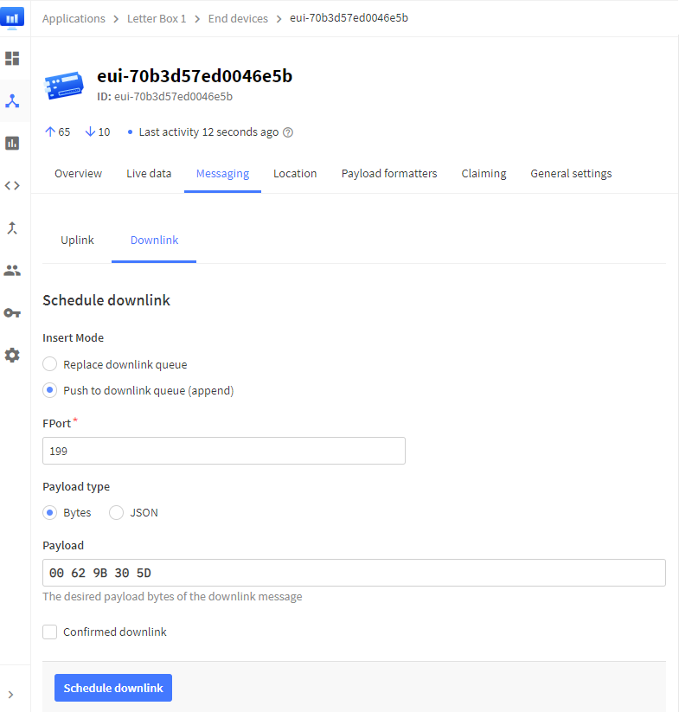
B) To read Epoch by distance

Syntax = Byte 0 = 01

Thus epoch will be provided at next Transmit

